SALIDA MUSEUM ASSOCIATION
NEWSLETTER
Serving the Salida Historic Area for Over 60 Years Fall 2017

Museum Goes to Winter Hours
The museum is now open for the winter season only on weekends. The hours of operation are now Saturday and Sunday, 1:00PM – 5:00PM. As usual, if you have a special request for a museum tour outside of normal operating hours, give us a call, and we will try to accommodate.
2017 Summer Season Visitors
We experienced another successful summer season, with visitor totals remaining stable and the number of special tours increasing. Summer Season visitors totaled 519, with 270 coming from Colorado, 94 coming from Chaffee County, and 84 coming from Salida. This is an increase in Salida visitors over past years, which is an encouraging indication of local interest in the museum.
Thanks to all our visitors. We hope to see you again.
Salida Museum
406½ West Hwy 50
Salida, CO 81201
719-539-7483
Salida Museum Board
President: Susan Jesuroga
Vice Pres: Bob Campbell
Secretary: Earle Kittleman
Treasurer: Larry Kovacic
Members: Judith Kinzie
Robin Rockney

www.salidamuseum.org

President’s Corner
What a summer! We not only celebrated the Smokestack’s 100th birthday on August 26, but on September 11, the Porter engine was moved from the west side to the front of the museum building to make way for some changes in the park. We’re tickled to have it out front of the museum to showcase such a great piece of Salida history. Thanks to the City of Salida and Terry’s Crane and Rigging for a smooth move. Next up will be some maintenance work on the engine and creating an informational sign about its history.
Come by and check out the engine. We’d love to tell you a story or two!
Susan Jesuroga, Museum President
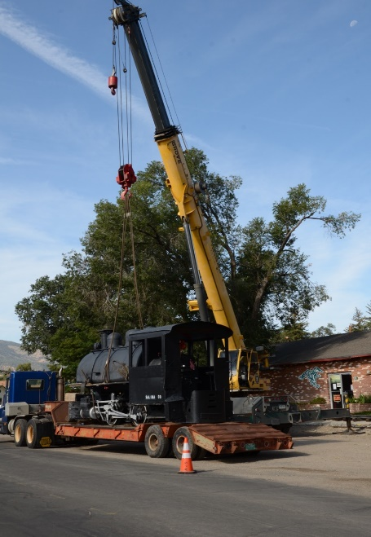
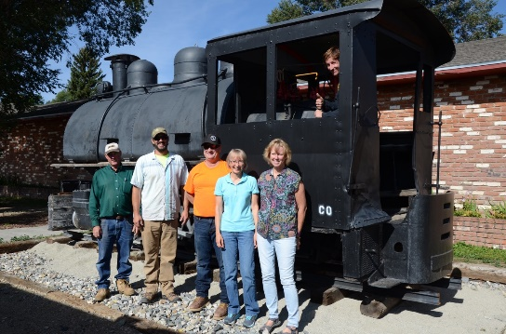
Little Goat
This little steam engine, or little goat or dinky, was donated to the Salida Museum in 1953 when the Koppers Company creosote plant in Smeltertown closed down. The creosote plant operated from 1926 until 1953, treating raw railroad ties with creosote as a preservative. The little goat pulled trains of flatcars, loaded with up to 600 railroad ties at a time, around the yard on 24-inch track. H.K. Porter Company of Pittsburg, PA, built a large number of light industrial steam engines in the early 1900’s, and this engine is most likely one of theirs. The engine is a type 0-4-0T, which refers to the wheel arrangement (zero pilot wheels, four driving wheels and zero trailing wheels). The “T” stands for “tank”, the water tank wrapped around the boiler, and the engine burned coal, carried in bunkers built into the cab. Come by and take a look at our new attraction!

Salida Museum Association
PRSRT STD
US POSTAGE
PAID
PERMIT NO. 75
SALIDA, CO
406 ½ W. Hwy 50
Salida, CO 81201
Return Service Requested

Salida Museum – Where the Past Informs the Present

Did You Know…
From the salidamuseum.org website: A local landmark, The Smokestack, is just a short trip northwest of Salida. The Ohio and Colorado Smelting and Refining Company built the 365 ft. structure in 1917, but it was used for only about 30 months before the smelter was closed in 1920. The base is concrete set on bedrock and is 40 feet wide, using standard gauge railroad rails set on end and crisscrossed horizontally 30 feet deep. The stack cost about $50,000 in 1917, $43,000 of that budget in brick. The original smelter was a 1200 ton per day facility dating from 1902. Toxic fumes from the original smelter stacks were said to be poisoning plants and animals downwind, so this higher stack was constructed in an effort to correct that problem. When the smelter closed in 1920, ownership changed hands several times, and the facility started to be slowly dismantled. After several attempts to tear down the high stack, ownership was granted to the Salida Museum, and the structure is now maintained as an historical monument. You can see the smokestack from all around the Salida area, and you can visit the site to read the interpretive signs installed several years ago in conjunction with the establishment of the Collegiate Peaks Scenic Byway. Note: Salida City Clerk Miss Bertie Roney was the first woman to reach the top of the new smokestack on November 14, 1917.
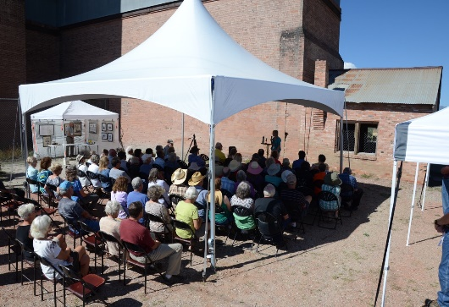
Museum News
2018 Museum Calendars Available. There are plenty of 2018 Salida Museum Calendars left, and they make great Christmas gifts. The theme of the calendar is Planes, Trains and Autos. Twelve black and white photos from the museum archives, along with information about each photo, grace the pages of this annual edition. At $15 each, these calendars are a great way to learn about Salida history while keeping track of the days. Pick up a calendar at the museum or at one of the local businesses carrying them. If you live out of town, we’ll send you one.
Salida Museum Website & Facebook Page. Visit the Salida Museum Website, www.salidamuseum.org, for articles on local history, events, photographs, quick facts, and other useful information. Also check out the museum Facebook Page, where you can search Salida Museum, read some interesting tidbits and look at photographs of museum artifacts along with historical photos. You can also access our page from the museum website.
Support the Salida Museum Association
- Donate to the Museum. Send a check to the address below. Amount donated _________.
- Join the Salida Museum Association. Annual membership is $15, lifetime membership is $100.
- Volunteer for the Museum and help with ongoing projects. We will contact you.

Date ___________________
Name _________________________________________
Address ________________________________________
City _______________ State ________ Zip __________
Phone __________________________
Email ___________________________
Mail this coupon with your payment to:
Salida Museum Assn., 406 ½ W. Hwy 50, Salida, CO 81201

Volunteers Needed. The museum is in need of more volunteers for the 2018 summer season. One of our docents is leaving, and the summer hours are getting to be a bit long for some others. If you are interested in Salida area history and would like to work at the museum, give us a call. We can divide the 6-hour day into two segments for a shorter shift, or we can make other arrangements. We can also use volunteers for help in other areas.

