SALIDA MUSEUM ASSOCIATION
NEWSLETTER
Serving the Salida Historic Area for Over 60 Years Spring 2018

2018 Summer Hours Begin Memorial Day
The Salida Museum well be open every day, 11:00am – 5:00pm, beginning the Memorial Day weekend. As usual, if you have a special request for a museum tour outside of normal operating hours, give us a call, and we will try to accommodate.
Museum Open House, May 12, 2018
Our annual free Open House, Saturday May 12, 11:00am – 5:00pm, will feature a program by Melanie Roth, president of Historic St. Elmo & Chalk Creek Canyon Inc. Melanie will be speaking on the history of our best preserved little mining town, St. Elmo, Colorado, and the ongoing preservation activities occurring there. Local author Wallace K. Ewing will also be talking about and signing copies of his recent book, “Focus on Salida”, co-authored with James P. Barnette. Check the museum website for further details.
Salida Museum
406½ West Hwy 50
Salida, CO 81201
719-539-7483
Salida Museum Board
President: Susan Jesuroga
Vice Pres: Bob Campbell
Secretary: Earle Kittleman
Treasurer: Larry Kovacic
Members: Judith Kinzie
Robin Rockney

www.salidamuseum.org

President’s Corner
This winter we lost two of our valued volunteers: Judy Micklich, long-time president and board member, and John Skinner, a long-time board member and all around volunteer. Judy started valunteering at the Museum in the late 1960s, working for our founder, Harriet Alexander and served as president from 1975 -2014. Through Judy’s tireless dedication to the Museum and preservation of area history, Salidans and history buffs from all over can still explore the museum and learn about the area’s long and colorful history. As Earle Kittleman wrote, “She personified the importance of hometown preservation.” Judy and her historical knowledge of Salida will be greatly missed. John Skinner was always willing to help with anything, from painting the walls, moving exhibits to raking the leaves out front. We will miss John’s thoughtful guidance to the Board, and his ready smile, often followed by a poem, a joke or a story or two.
A non-profit like the Museum is only as good as the volunteers that show up to do all the work that always seems to need be done. All of our volunteers are everyday heroes to me, by willingly investing their free time into the Museum’s mission to preserve our community’s history. I greatly appreciate them all! And if you would like to join in our merry band, we’d love to hear from you. We need all sorts of skills for our cause to: be a docent, create exhibits, help with events, handle our social media, do some fundraising, or just help us paint, clean, take care of the flower beds or anything else you might want to do. Give me a call and let’s talk how you might help us keep the doors open and our patrons coming back for more.
Susan Jesuroga, Museum President
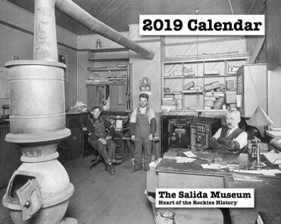
2019 Calendar
The 2019 Salida Museum Calendar will be available at the Museum and at select retailers around Salida through the end of the year. We have sold out every year since 2016 so it continues to be a great fundraiser for the Museum. The theme for this year is “Interiors”. Have you ever driven past an old house or building and wondered, who lived there and how did they spend their days? With all the old, downtown brick buildings and wonderful old Victorian houses, we decided to provide a peek at how business owners and residents lived and worked in the early days of Salida. Check it out at the Open House.
Salida Museum Association
PRSRT STD
US POSTAGE
PAID
PERMIT NO. 75
SALIDA, CO
406 ½ W. Hwy 50
Salida, CO 81201
Return Service Requested

Salida Museum – Where Local History Comes to Life

Did You Know…
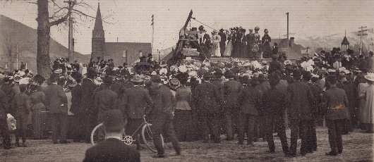
The Salida Tuesday Evening Club disbanded in 2005 to little fanfare after more than 100 years of service to community improvement and cultural enrichment, the most lasting gift of which is Salida’s public library. The ladies who organized the Tuesday Evening Club in 1894 made building the library their first goal and began using dues to purchase books. Mrs. A.C. Ridgway, the club’s first president, donated three vacant lots at 4th and E Streets, and the club raised the funds to match a Carnegie grant. The cornerstone was laid in 1908, and the library was open to the public a year later. William Penn Harbottle, a wounded CivilWar veteran, bequeathed his Salida home and personal book collection; the books were housed in the Julianna Reference Room named for his mother. Rent from the Harbottle property helped fund the library for years. Club ladies met year round to discuss literature, present musicals, raise money for charity, and urge civic action. They held meetings and parties in the basement of the library and started scholarships for deserving girls while continuing to acquire books and make library improvements During the war years they organized Red Cross drives, sewed bandages, held First Aid classes and book drives, hosted the USO, and purchased war bonds. Archives, photos and memorabilia of the Tuesday Evening Club were donated to the Salida Museum and are on display in a newly reorganized exhibit. The late Judy Micklich, president of the Salida Museum for many years, was one of the last members of the club. We are indebited to Judy’s stewardship, exemplified in the motto of the Tuesday Evening Club: Operae Pretium Est (It Is Worthwhile). Earle Kittleman, Museum Secretary

Museum News
Museum Exhibits Relocated. This past January we closed down the museum and worked on moving several exhibits. The Railroad and Mining exhibits were moved to a more visible location in front of the North room main doors in order to emphasize their importance in Salida history. The Medical and Tuesday Evening Club exhibits then went into the South room where they complimented many of the exhibits already there. We also received an antique display cabinet that was used to better display the articles in the Fashionable Ladies Exhibit. The overall effect is very pleasing; come by and see.
Porter Engine Restoration. Fundraising efforts have already begun to raise money for some limited restoration work on the Porter Engine in front of the museum. A team of experts from New Mexico has offered to do as much work as we can afford. They will sandblast and paint the engine as it originally looked, and if possible, they will replace some of the missing parts, like the light lens and bell. If you want to help, designate your donation to the Engine Fund.
Support the Salida Museum Association
- Donate to the Museum. Send a check to the address below. Amount donated _________.
- Join the Salida Museum Association. Annual membership is $15, lifetime membership is $100.
- Volunteer for the Museum and help with ongoing projects. We will contact you.

Date ___________________
Name _________________________________________
Address ________________________________________
City _______________ State ________ Zip __________
Phone __________________________
Email ___________________________
Mail this coupon with your payment to:
Salida Museum Assn., 406 ½ W. Hwy 50, Salida, CO 81201

